**Creating Microservices for Account and Loan**

This exercise walks you through developing two separate microservices using Spring Boot: one for managing account data and another for handling loan details. Each service will be created as an independent Maven project with its own configuration, running on different ports. These microservices will return hardcoded data and won’t connect to any backend or database.

**Prepare Your Workspace**

1. Navigate to your D: drive.
2. Create a folder named after your employee ID (e.g., D:\123456).
3. Inside it, create another folder called microservices. This is where you’ll store the projects you'll create.

**Build the Account Microservice**

**Use Spring Initializr**

1. Open <https://start.spring.io> in your browser.
2. Fill in the form as follows:
   * Group: com.cognizant
   * Artifact: account
3. Add the following dependencies:
   * Spring Web
   * Spring Boot DevTools
4. Click **Generate** to download the ZIP file.

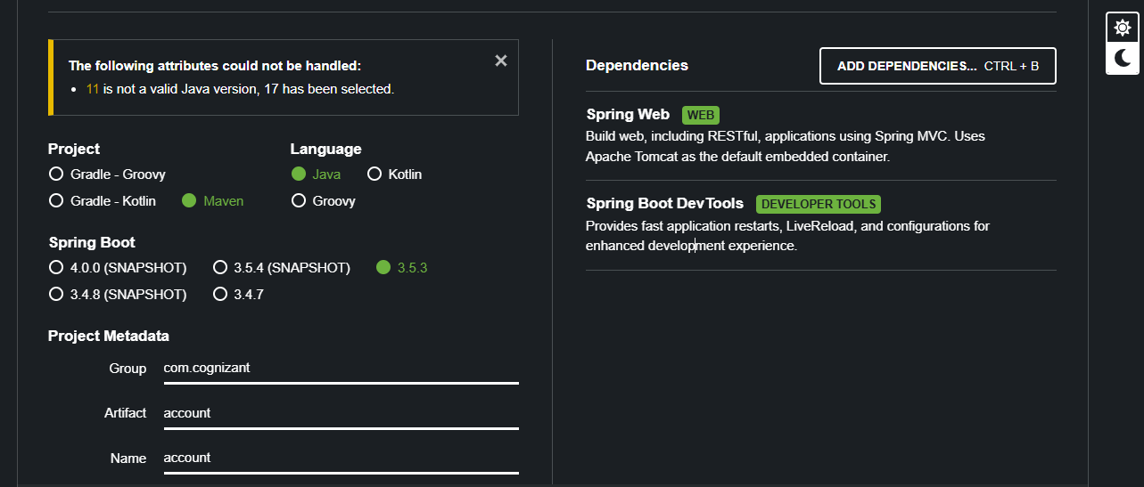

**Set Up and Build**

1. Extract the downloaded archive.
2. Move the account folder to D:\<your_employee_id>\microservices.
3. Open a terminal in that directory and run:

“mvn clean package”

**Develop the Account Service**

**Import Project into IDE**

* Open Eclipse and go to File → Import → Maven → Existing Maven Projects.
* Select the account folder to import the project.

**Organize Code**

Create the following structure within src/main/java/com/cognizant/account:

* A package named model, containing Account.java
* A package named controller, containing AccountController.java

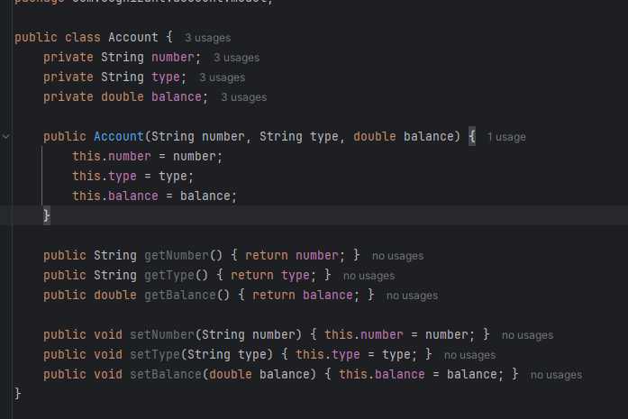

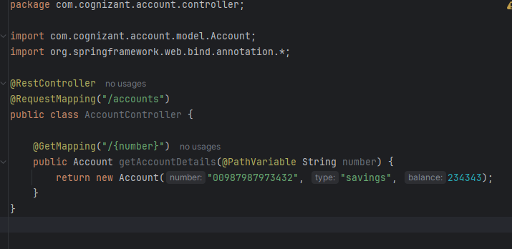

**Test the Account Endpoint**

1. Start the application by running AccountApplication.
2. Visit the following endpoint in your browser or via Postman:

“http://localhost:8080/accounts/123”

The response should be a fixed JSON object representing an account.

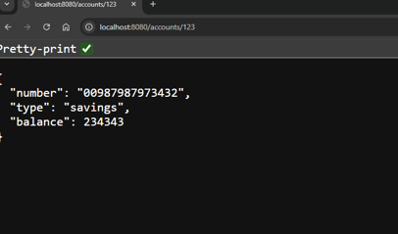

**Set Up the Loan Microservice**

**Generate Another Project**

1. Return to <https://start.spring.io>.
2. Enter the following:
   * Group: com.cognizant
   * Artifact: loan
3. Add:
   * Spring Web
   * Spring Boot DevTools
4. Generate and extract the project.
5. Move the loan folder into your microservices directory.

**Configure Port for Loan Service**

To avoid port conflicts with the Account service, configure the Loan service to run on a different port:

1. Open src/main/resources/application.properties.
2. Add:

“server.port=8081”

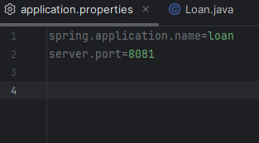

**Build Loan Service Logic**

Under src/main/java/com/cognizant/loan, create:

* A Loan.java
* A controller LoanController.java

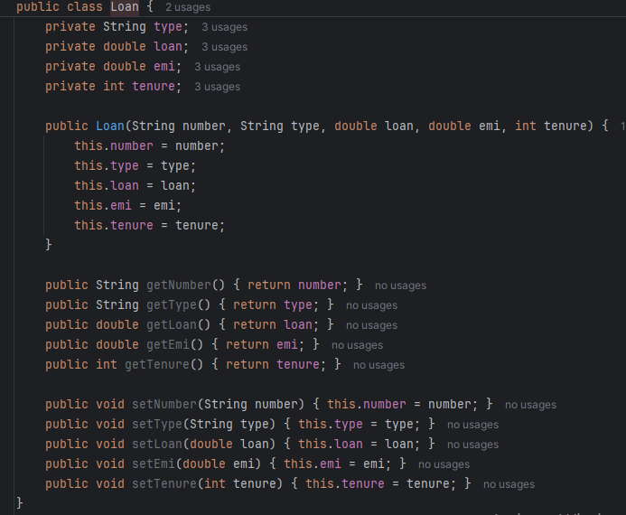

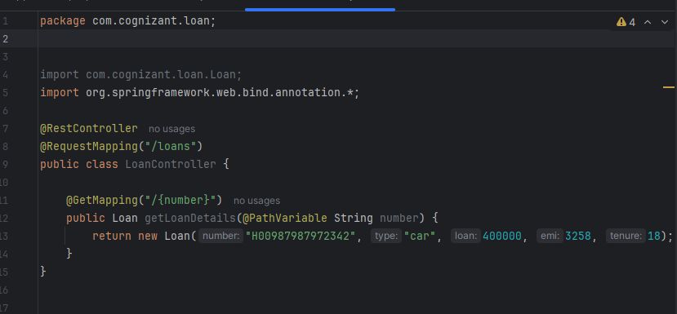

**Verify Loan Service Functionality**

1. Ensure the Account microservice (on port 8080) is already running.
2. Start the Loan microservice.
3. In a browser or using Postman, access:

“http://localhost:8081/loans/456”

This should return a JSON object with dummy loan details.

